Mini Project 2

ITMD 515

**TABLE OF CONTENT :**

Objective: 2

About the application: 2

Requirement fulfillment: 2

Design: 2

Design Diagram : 2

Welcome page / Main page: 2

Description: 2

Screen Shots: 2

Create Customer Page : 2

Description: 2

Screen Shots: 2

Read Customer Page: 2

Description: 2

Screen Shots: 2

Update Customer Page: 2

Description: 2

Screen Shots: 2

Delete Customer Page: 2

Description: 2

Screen Shots: 2

Menu Side Bar: 2

Description: 2

Screen Shot: 2

Error Page: 2

Descripton: 2

Screen Shots: 2

Development Insights: 2

Installation Information: 2

Software required to install, 2

Steps involve in Compilation and Run: 2

Expected Results: 2

## 

## Objective:

This application is designed to perform CRUD Operations.

In computer programming, create, read, update and delete (as an acronym CRUD or possibly a backronym) (Sometimes called SCRUD with an "S" for Search) are the four basic functions of persistent storage. Sometimes CRUD is expanded with the words retrieve instead of read, modify instead of update, or destroy instead of delete. It is also sometimes used to describe user interface conventions that facilitate viewing, searching, and changing information; often using computer-based forms and reports.

## About the application:

Having an objective to perform CRUD operations, this application ‘C’reates a new customer where user need to provide all his personal information like name, address, email, contact number etc., Once the user creates new customer he can ‘R’ead, ‘U’pdate and ‘D’elete the information from the database.

## Requirement fulfillment:

1. Application is created using two table from sakila database, i.e customer table and address table.
2. Data Source and Resources are created as per naming convention.
3. Implemented MVC pattern.
4. Validation for each and every field for the input.
5. Page has MENU option in the header and so user can navigate to any page so that there is no dead-end page.
6. This application has Welcome Page (index.jsp) which allow user to do Create and Read customer.
7. Read customer can choose the customer and Update or Delete that particular row as per requirement.
8. After READ, UPDATE and DELETE user is navigated back to READ customer page.

## Design:

In this section I will discuss about each page in the application with description and screen shots.

### Design Diagram :

* + Database Used : sakila ( MySQL)
  + Tables : customer and address

**WELCOME PAGE**

READ OPERATION

CREATE OPERATION

DELETE OPERATION

UPDATE OPERATION

**ERROR PAGE**

### 

### Welcome page / Main page:

#### Description:

This page has two links where user can create a new customer or user can navigate to read customer page where he can get complete details of the customer. There is menu on left top navigation where user can navigate through out the application for CRUD operations.

Javadoc is embedded in this page, which navigates to Javadoc.html

#### Screen Shots:

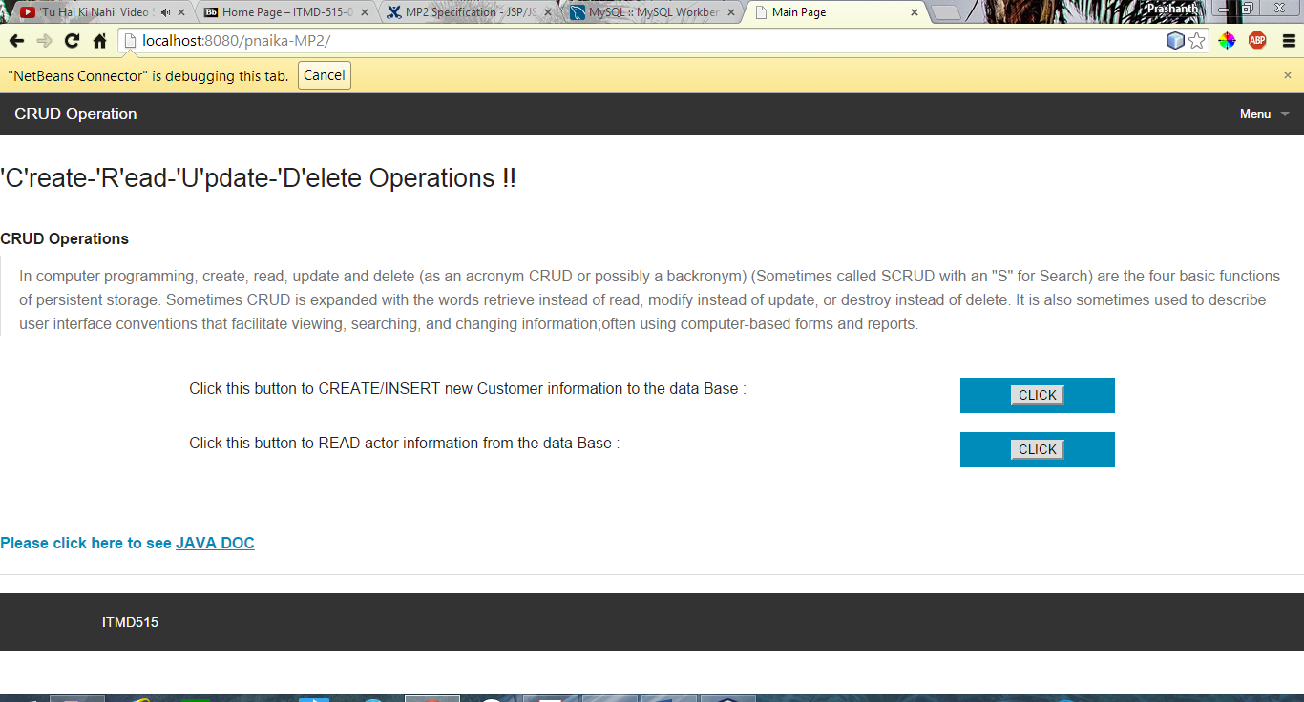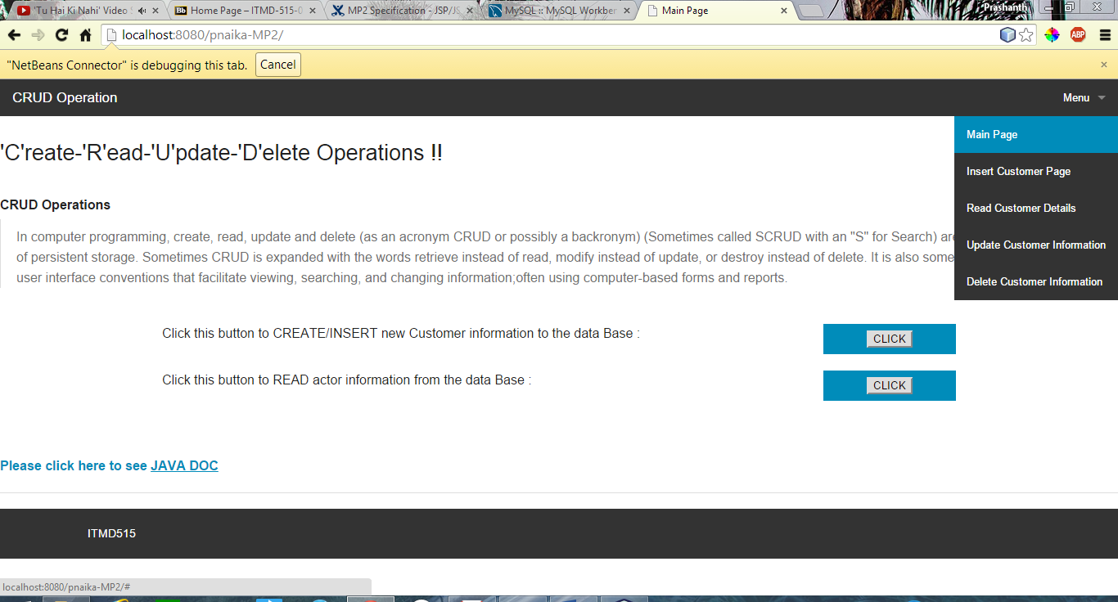

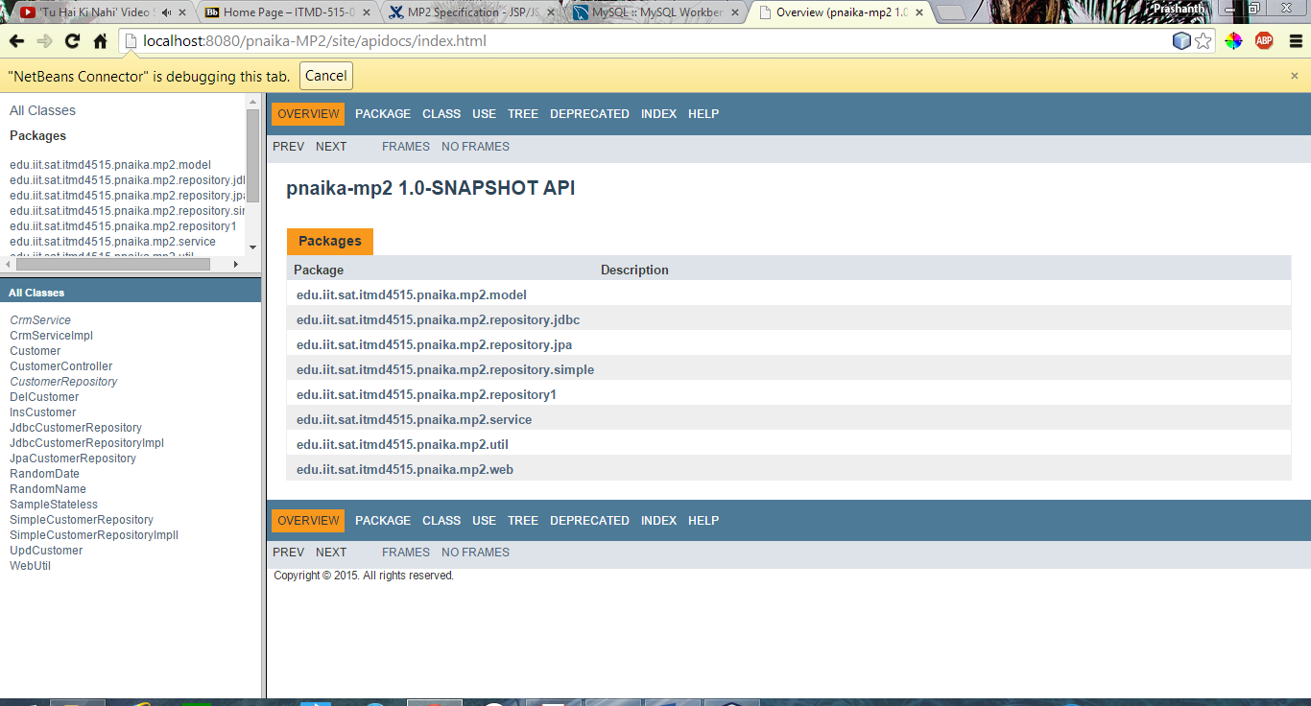

### Create Customer Page :

#### Description:

This page allows user to create a new customer in the database. It has following fields

* First Name
* Last Name
* Address
* District
* Email
* Phone

Apart from ‘district’ field all other fields are mandatory and if user did not enter the required data then application will prompt a message and highlight the field to be entered.

#### Screen Shots:

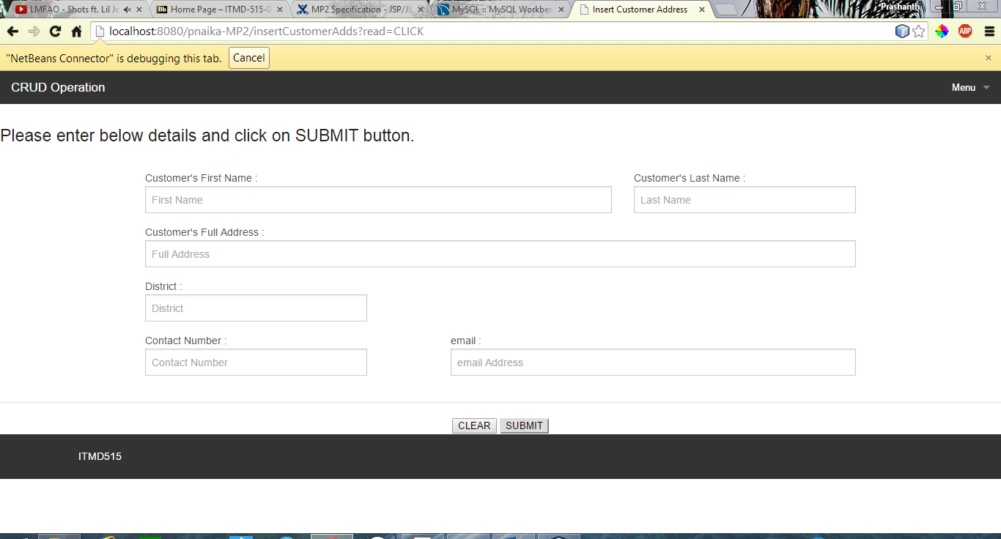

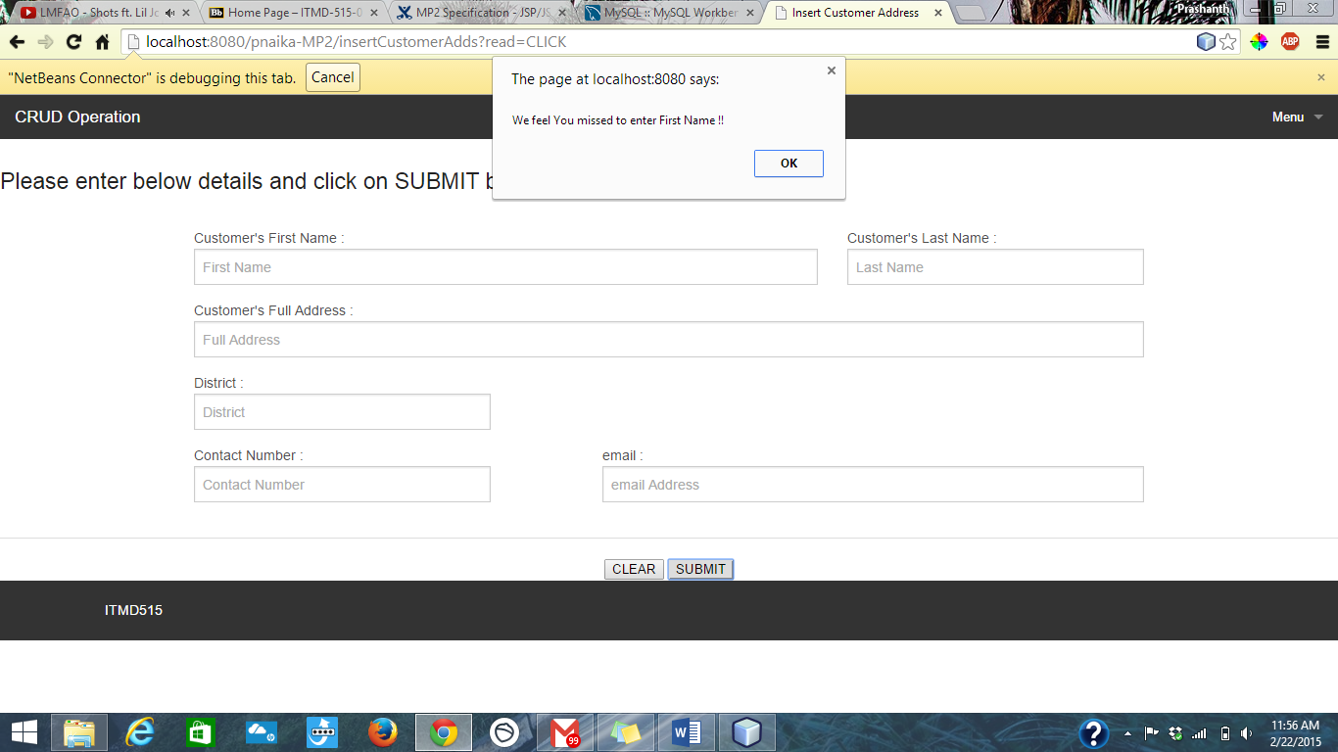

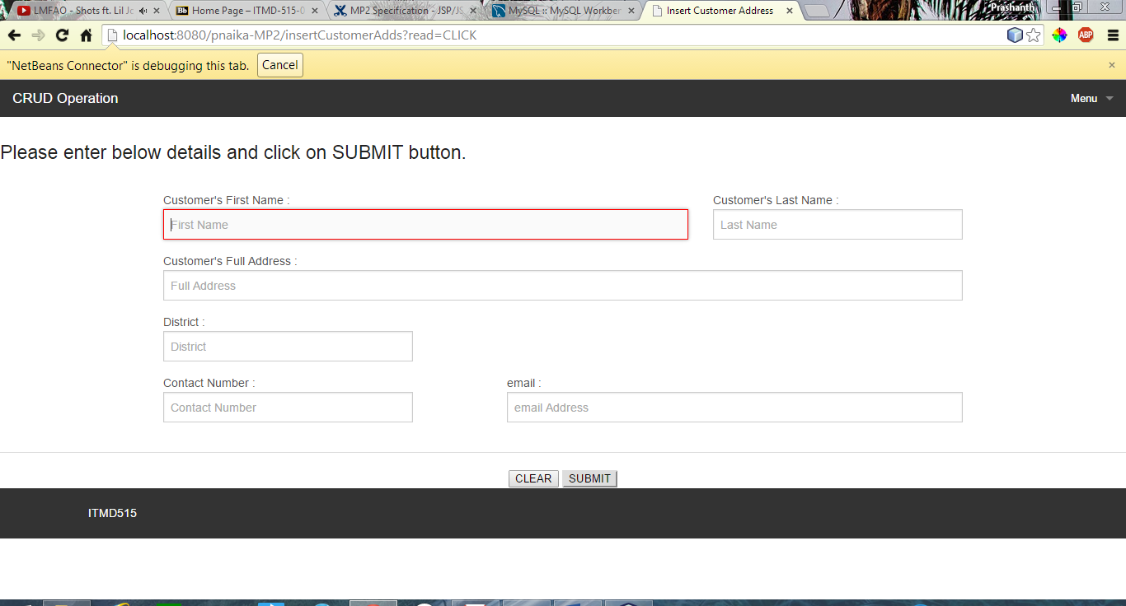

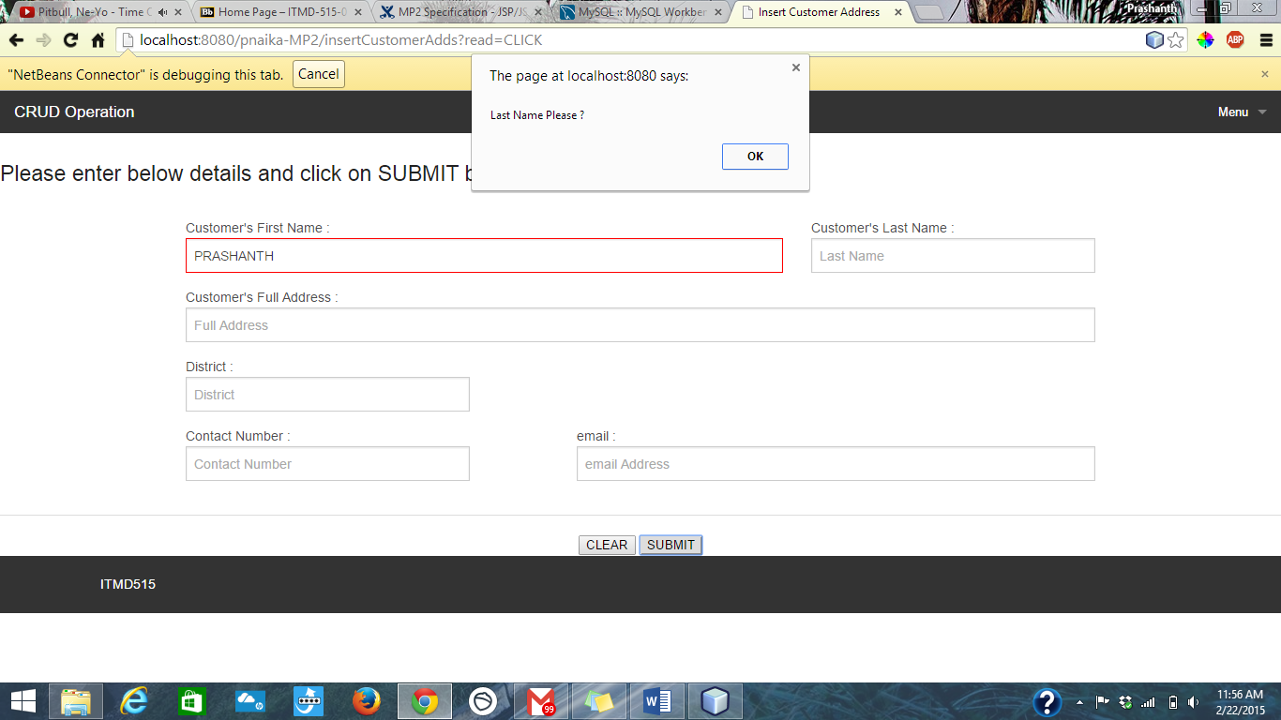

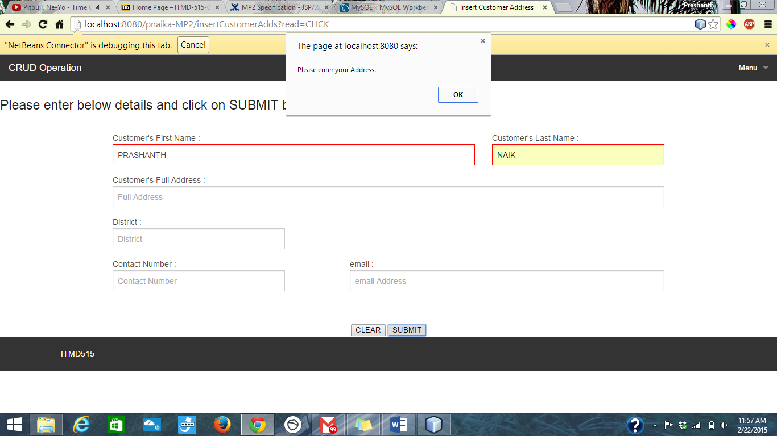

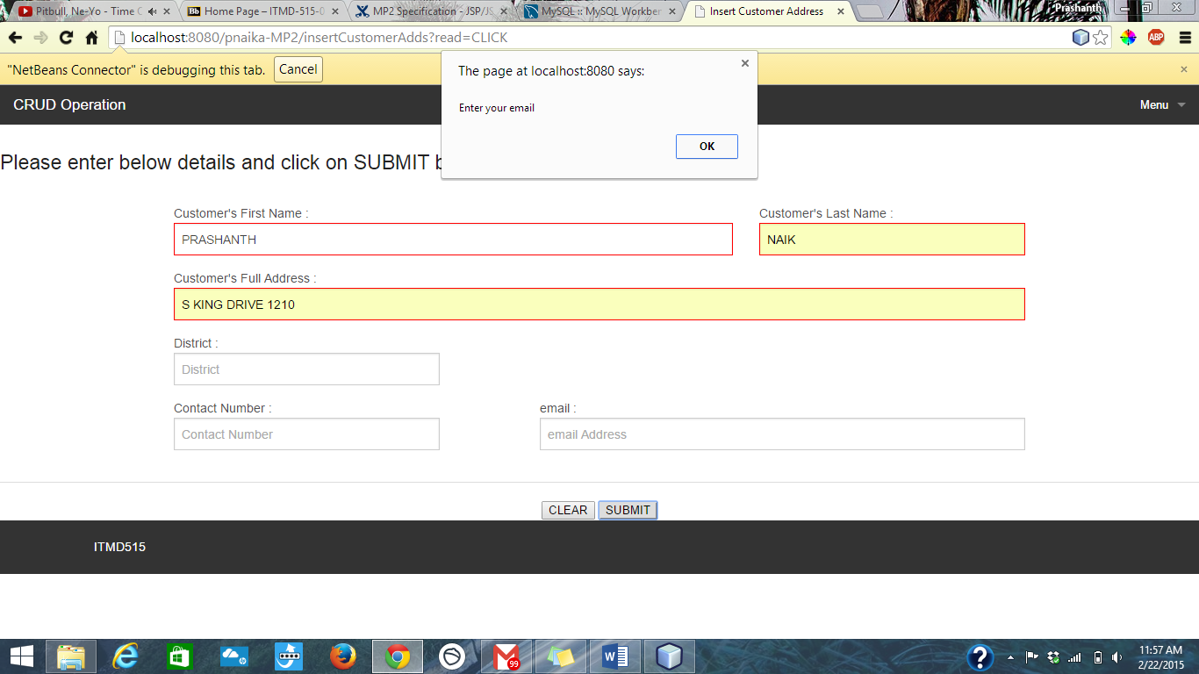

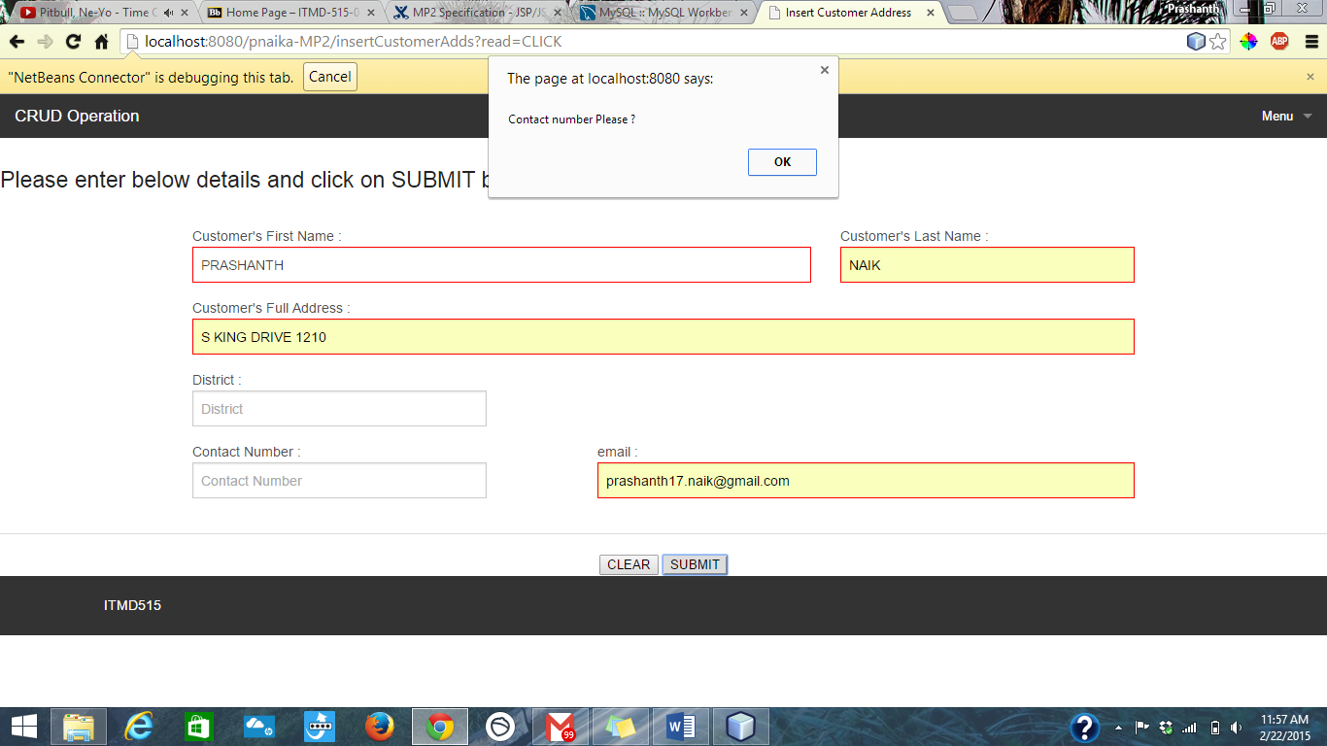

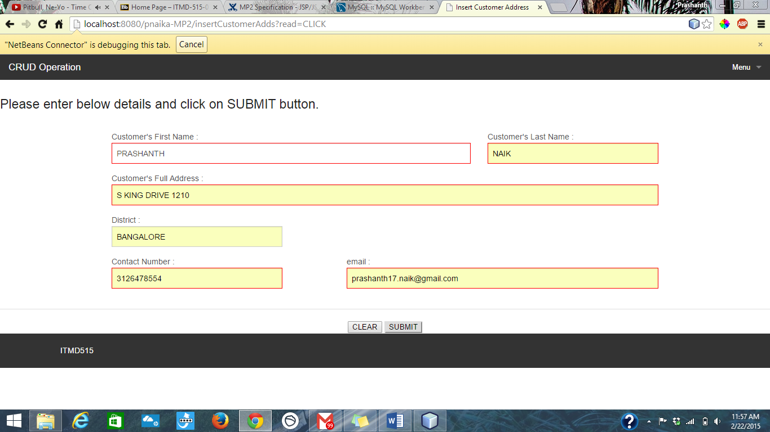

Page will navigate to READ PAGE , refer below to get the Customer ID and input Customer ID to Verify if new customer is created or not.

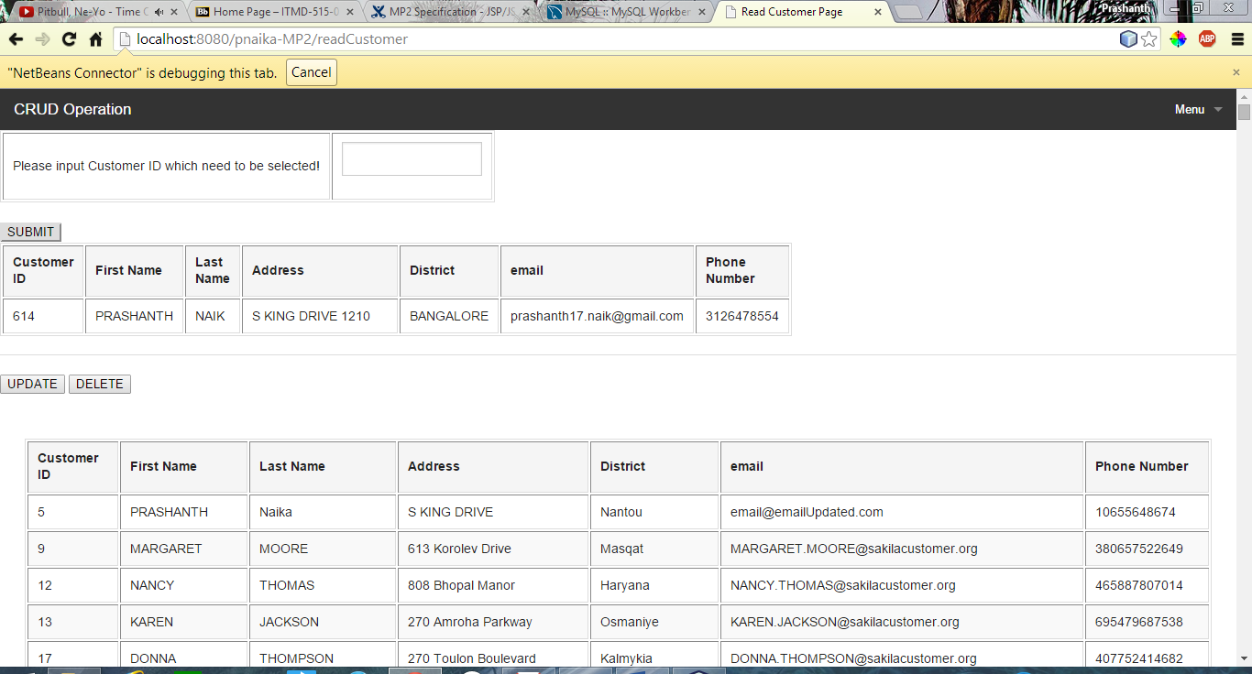

### Read Customer Page:

#### Description:

This page will read the customer details and display in the page, This page also has information of all the customers. User will be prompted to input Customer ID which need to be read. Once user get the details, he can go ahead either UPDATE or DELETE the selected customer. Customer ID is a mandatory field.

#### Screen Shots:

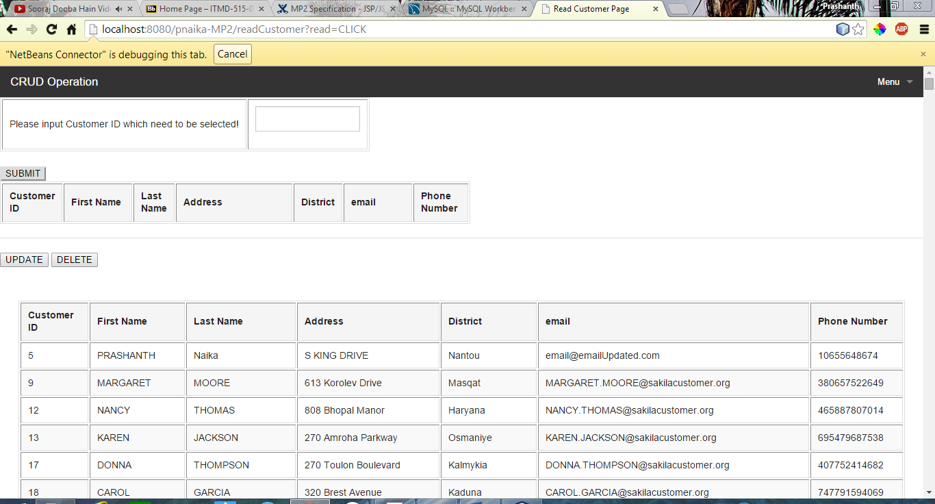

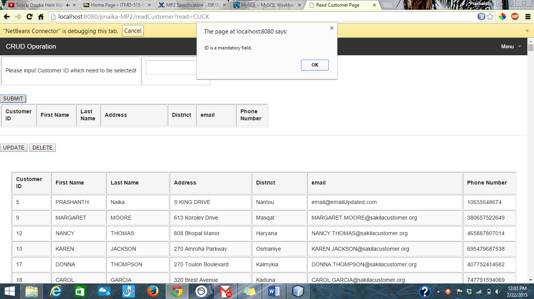

Entered customer ID as ‘5’ in this case.

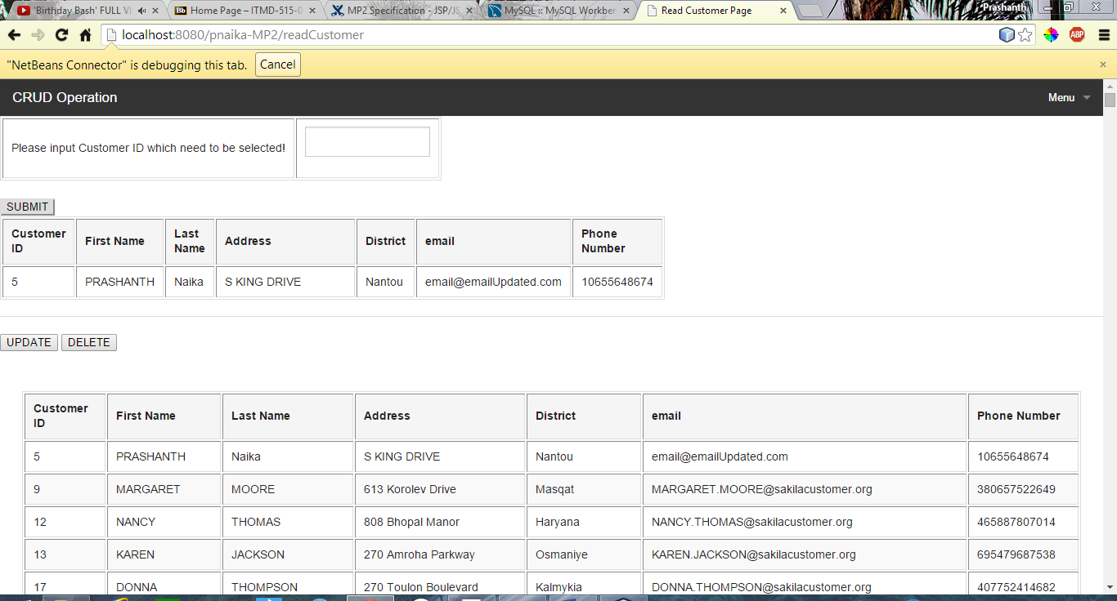

### Update Customer Page:

#### Description:

This page will update customer information that is entered in READ CUSTOMER PAGE. It has all the fields which was there in Create Customer page and so apart from District field all other fields are mandatory.

#### Screen Shots:

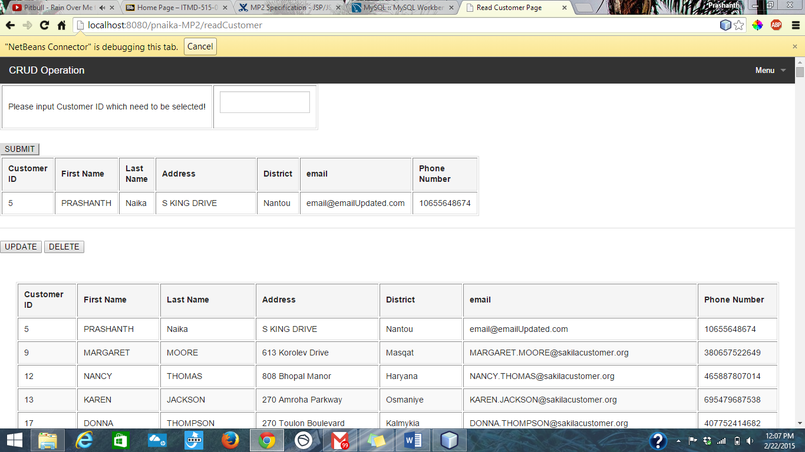

Click on UPDATE button

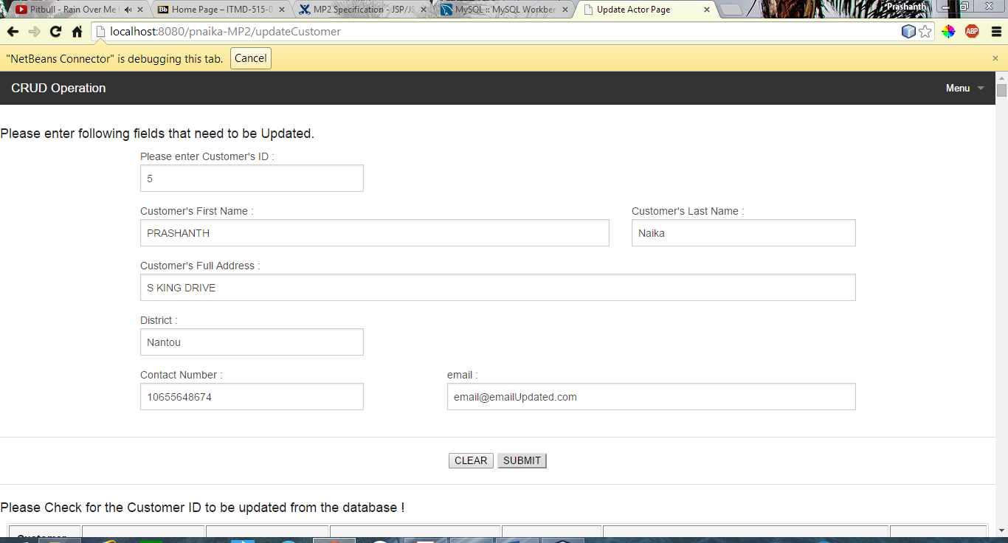

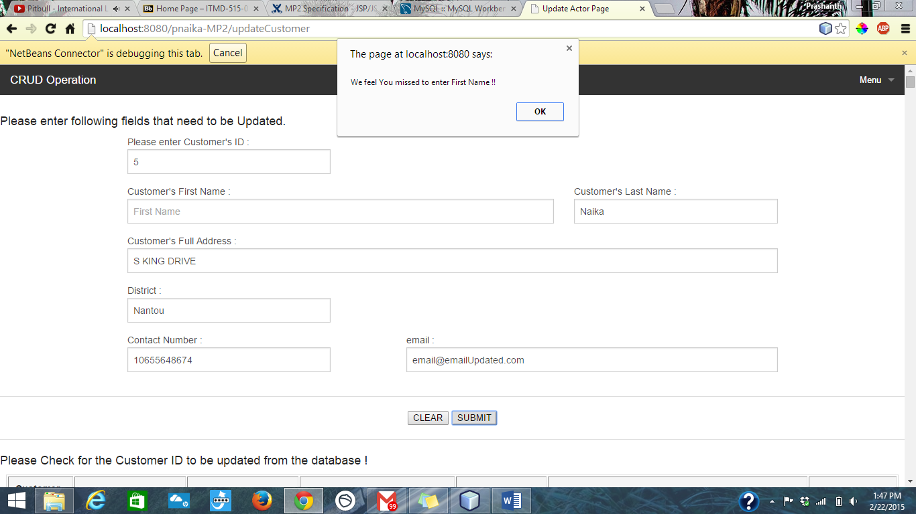Validation has been done for all the mandatory fields except DISTRICT

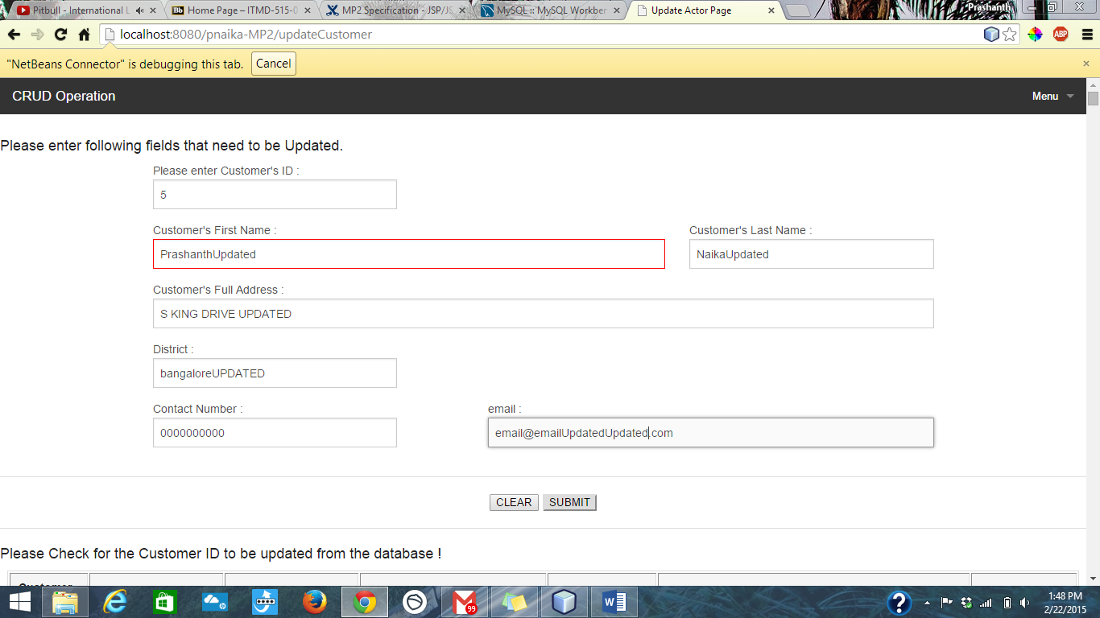Entered all the values as shown above

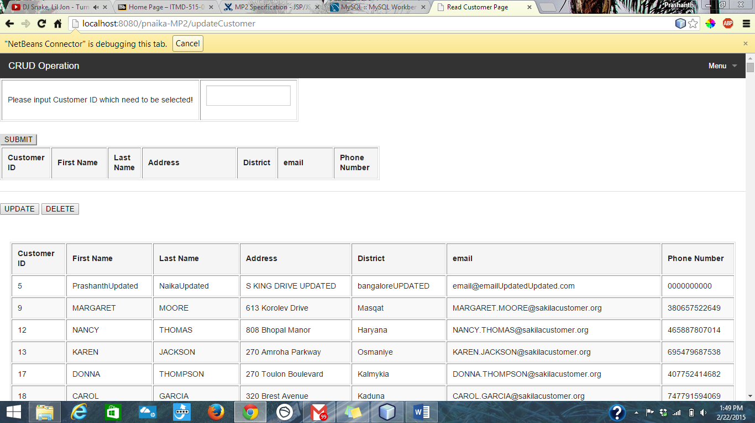

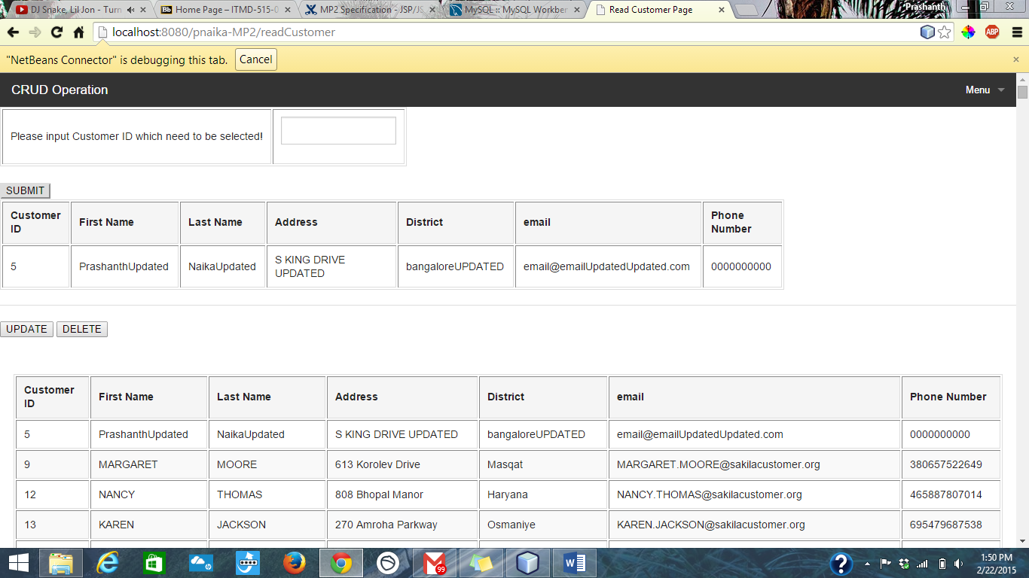

### Delete Customer Page:

#### Description:

This page will allow user to Delete customer from the application. Once the user reach Read customer page and input Customer ID , upon clicking on DELETE button, user will be provided with Customer ID and Customer full name for verification, Customer ID is mandatory field. Upon clickinig on OKAY button , selected customer will be deleted from the database.

#### Screen Shots:

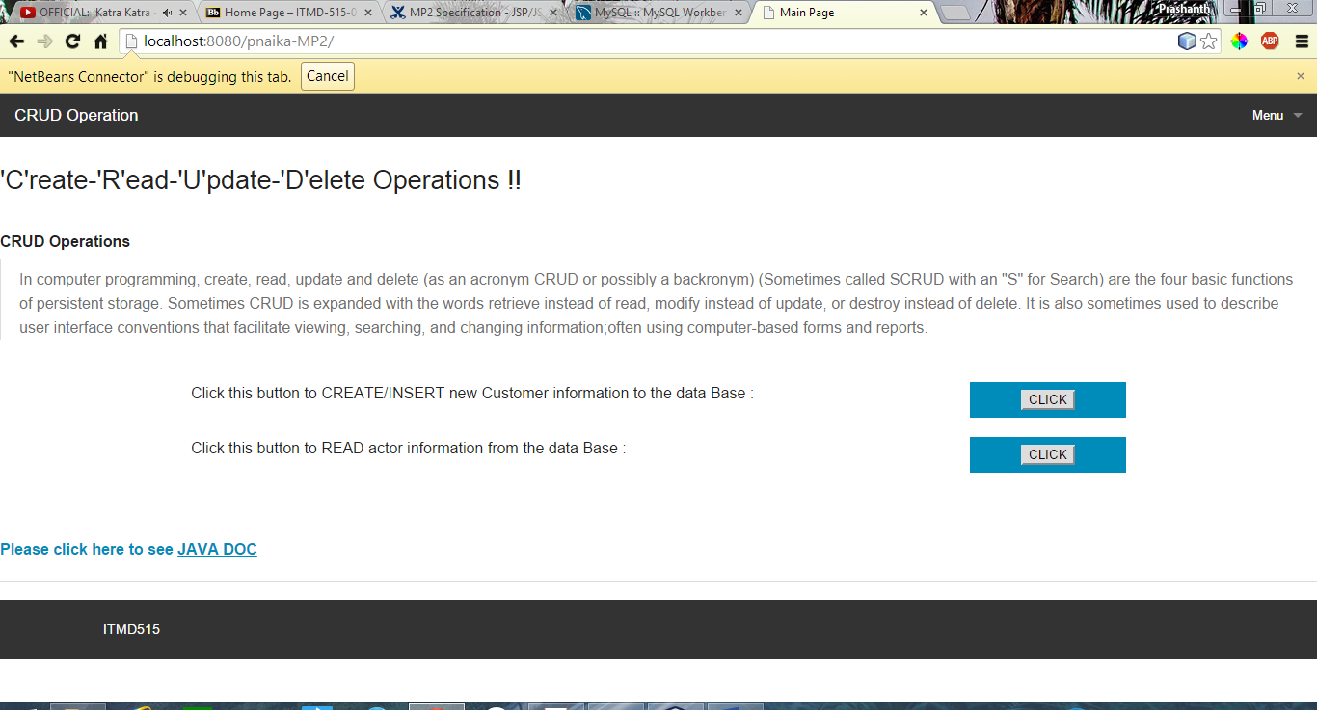

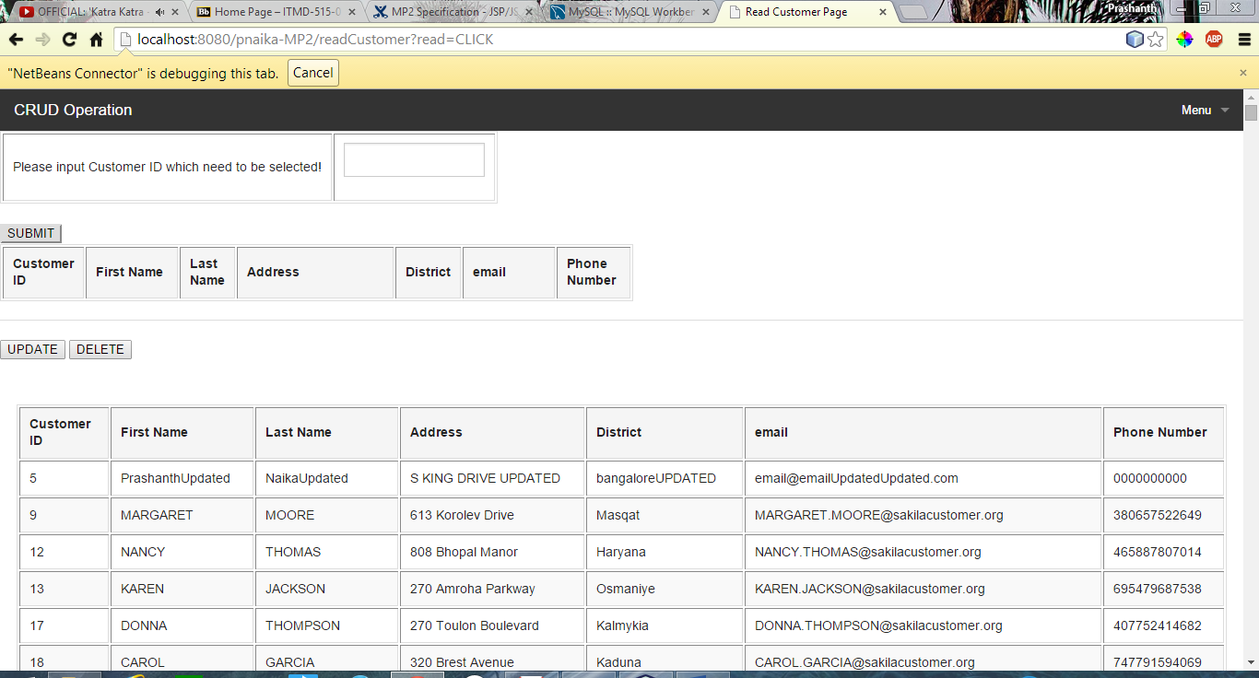

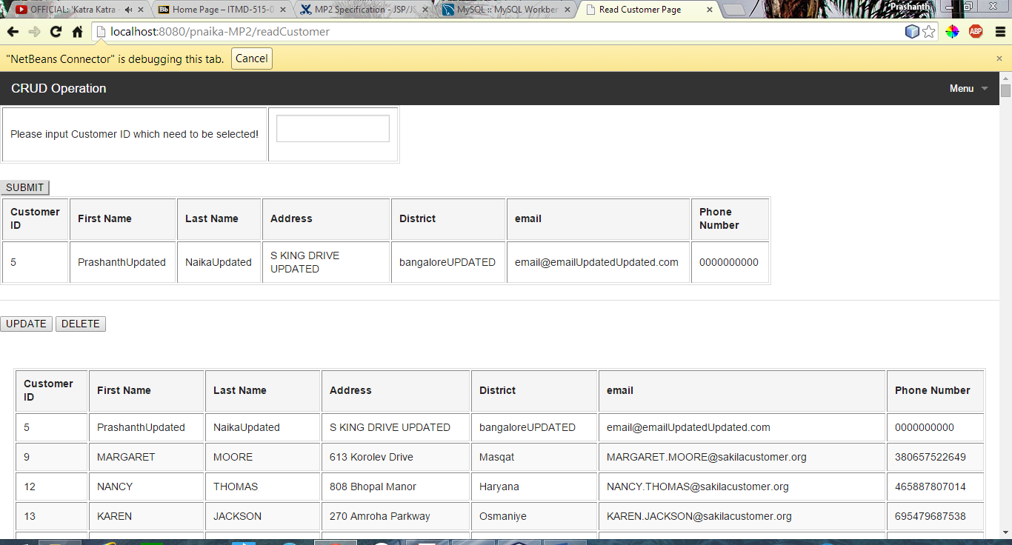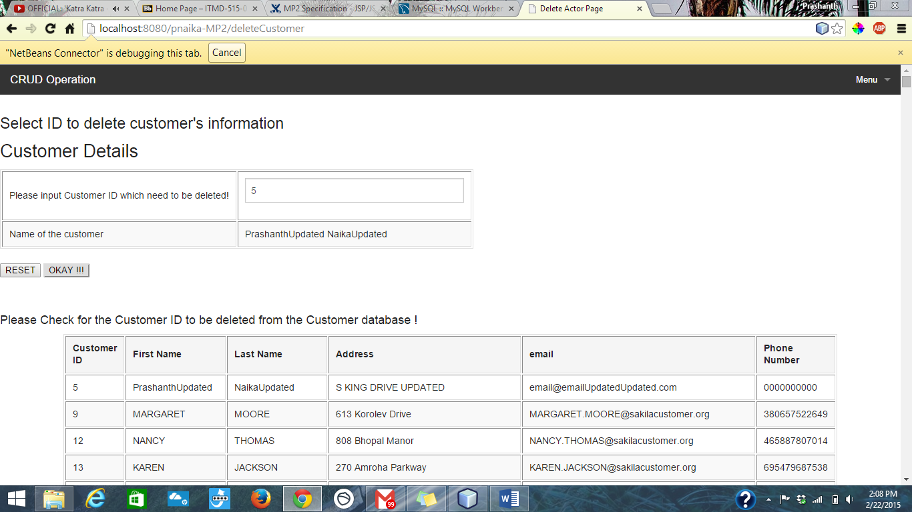 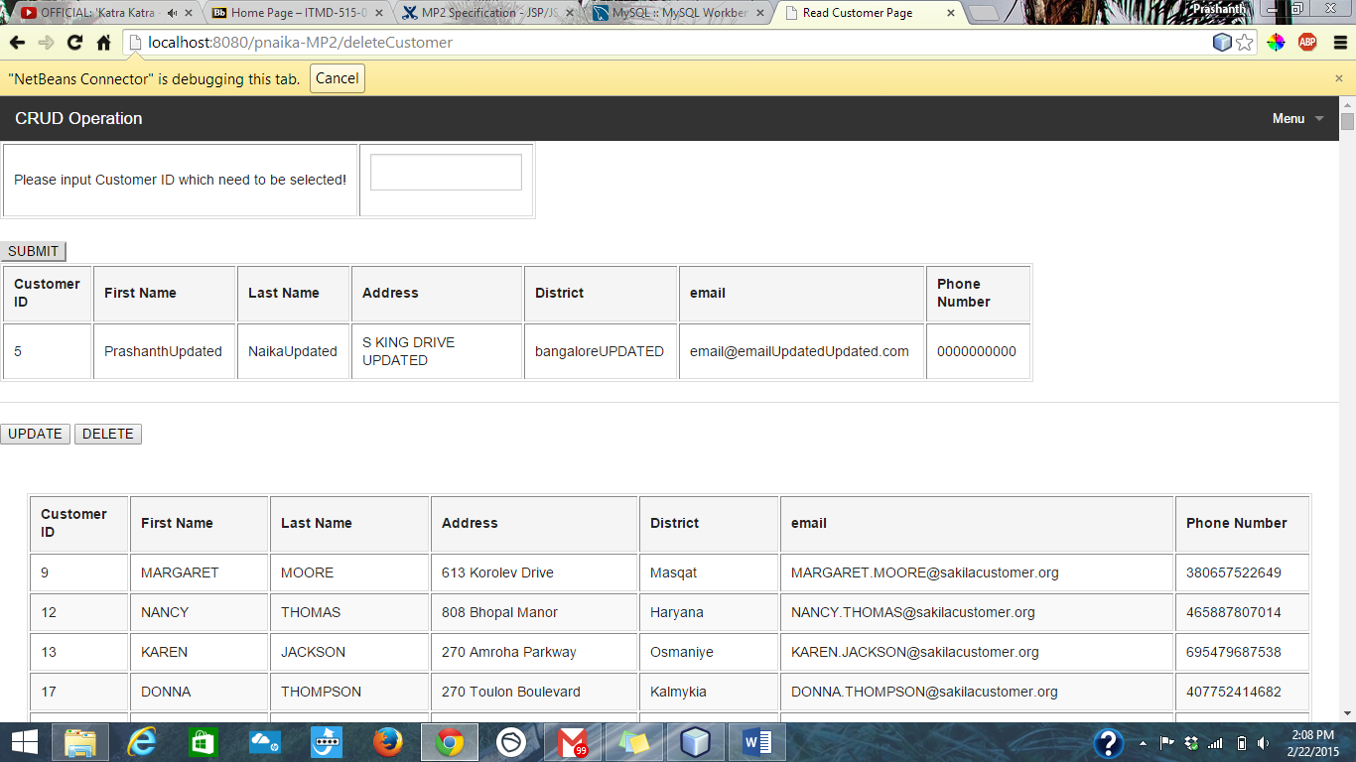

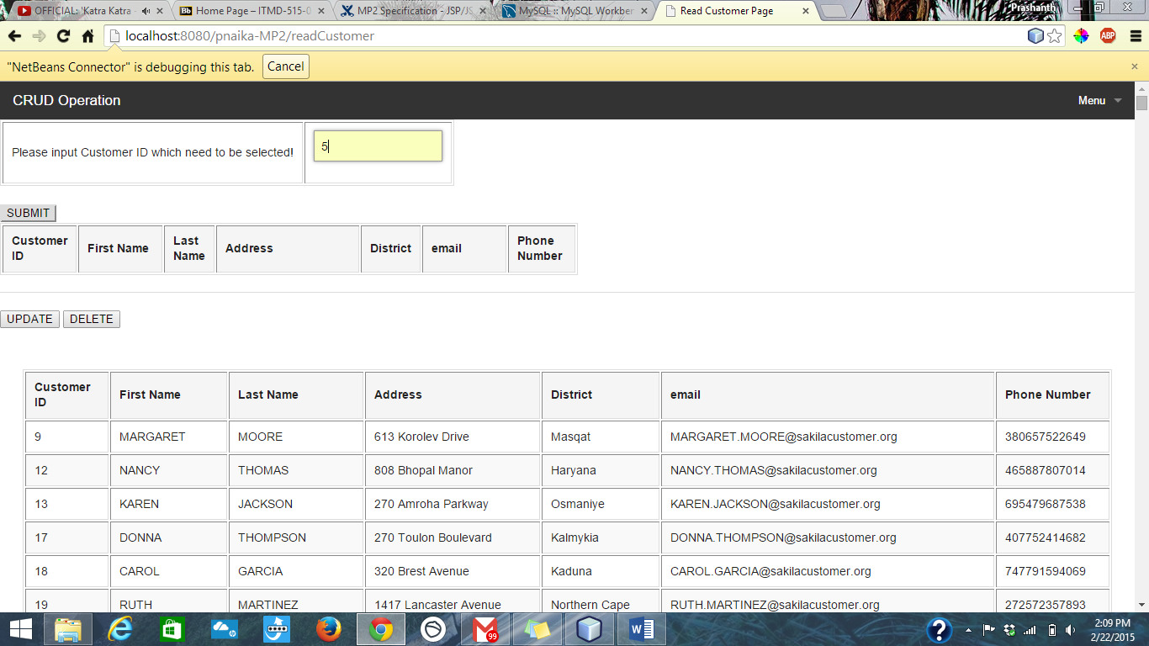

If I erase Customer ID and click on OKAY !!

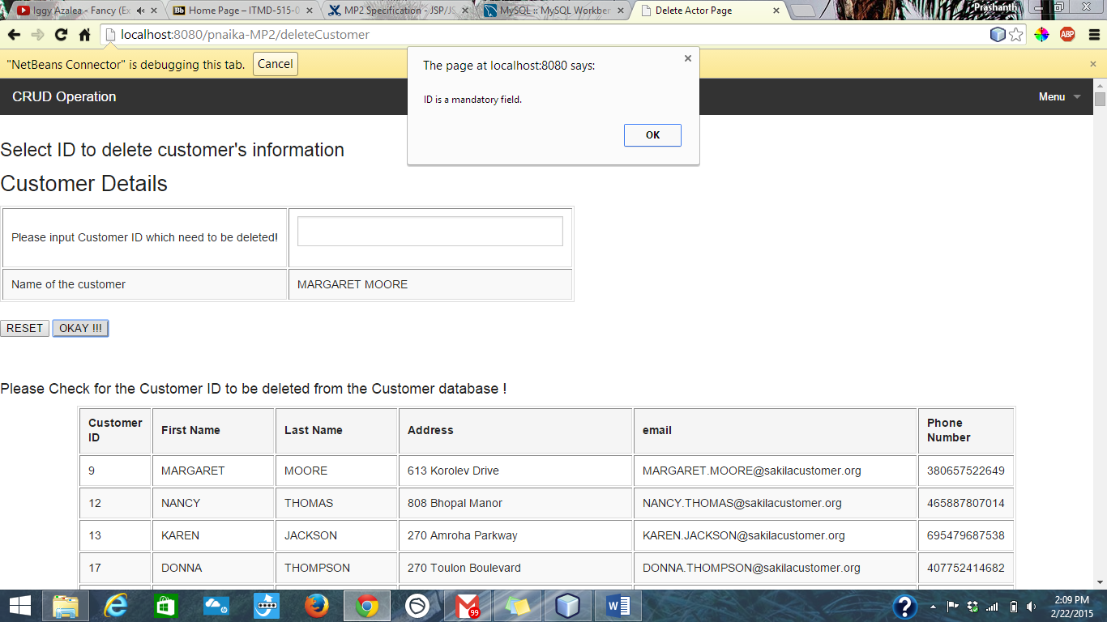

### Menu Side Bar:

#### Description:

There is a MENU bar towards left hand which helps to navigate complete application.

#### Screen Shot:

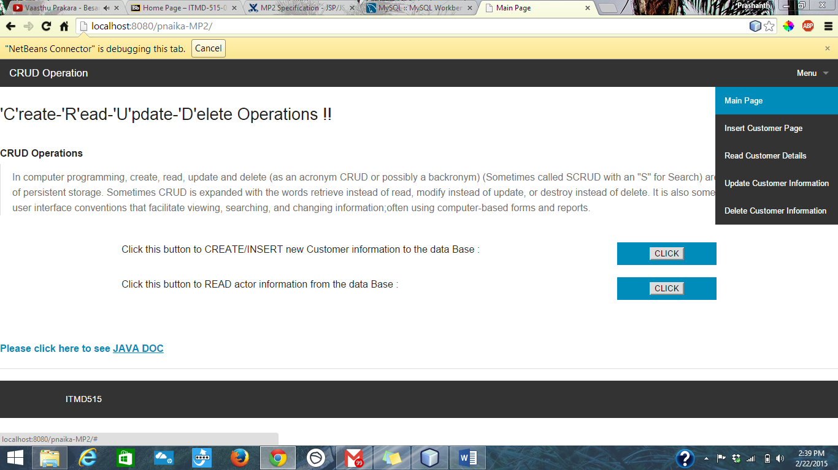

### Error Page:

#### Descripton:

This page will trigger whenever an error occur. It has the information about status code and exception details, that will help developer to decode the error if happened.

#### Screen Shots:

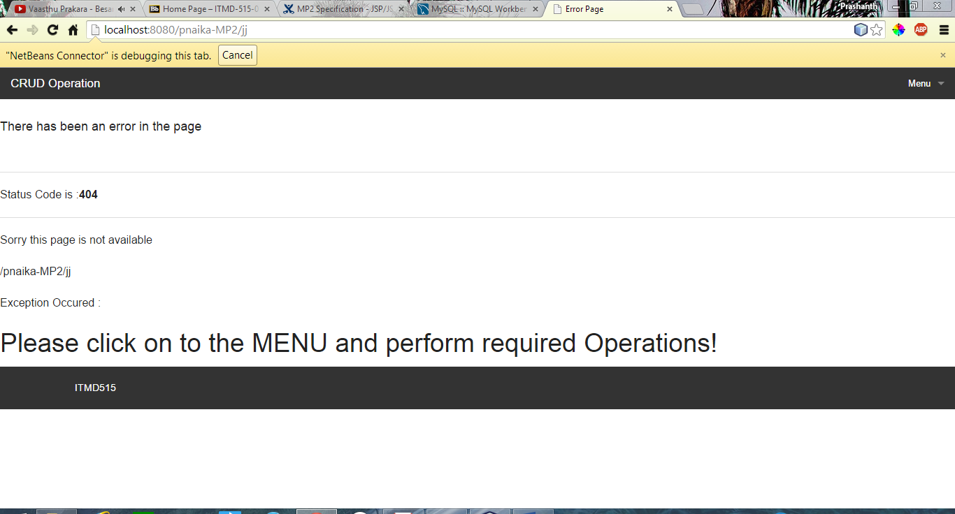

## Development Insights:

* Experience includes exploring more in MVC coding technology
* Good handson on J2E
* Got familiar with JSP, Servlets , MVC and Net Bean tool

## Installation Information:

### Software required to install,

1. NetBean 8
2. MySQL
3. Latest JDK 8

### Steps involve in Compilation and Run:

1. Code JSP, .java and Servlet
2. Make connection in Service tab 🡪 database
3. Create Pool and Data Source
4. Complete the code.
5. Click on Clean and build 🡪 Run.

## Expected Results:

* Successfully performing CRUD operation.
* Dead end less application
* Error catch
* Validations